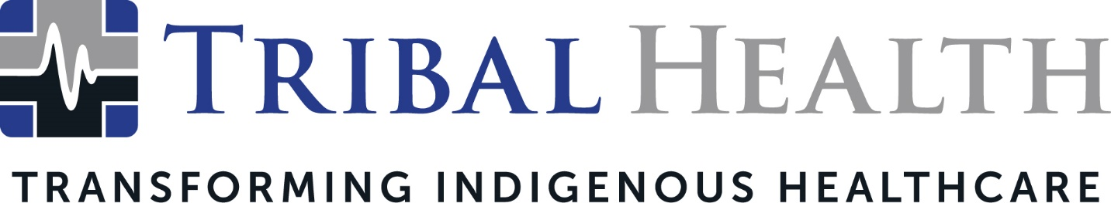

Tribal Health Names TJ Kline as Chief Operating Officer

SCOTTSDALE, Ariz. (Dec. 17, 2024) – Tribal Health, the industry leader in healthcare solutions for Native American communities, today announced the promotion of TJ Kline, MBA, to Chief Operating Officer. Kline will lead and scale the company’s national business operations to support the company’s ongoing commitment to healthcare excellence and transformation.

Kline has served Tribal Health in a financial management role since its early days, helping to fuel the company’s consistent expansion. A committed advocate for the democratization of healthcare, Kline previously played an influential role at telemedicine leader MeMD and supported a national expansion of behavioral health facilities. He is also a venture capital associate at Xcellerant Ventures, which partners with innovative healthcare technology startups.
Chief Executive Officer Morgan Haynes praised Kline’s expertise in healthcare operations and federal systems, saying she was thrilled to expand his scope to COO.
“Since cutting the first company check in 2015, TJ has driven Tribal Health’s momentum,” said Haynes. “He immediately established himself as a natural and transformative business leader, able to deliver measurable results through both his meticulous fiduciary management and his empathetic approach to building high-performing teams. Operations are at the heart of how we serve our clients and I am confident TJ’s gift for building key relationships and aligning operational and financial functions will intensify our long-term impact.”
Chief Financial Officer Ashley Sanders commented, "TJ’s creative spirit, innovative approach, and unwavering dependability have consistently elevated our work. His remarkable growth and dedication have set a high standard of excellence and we look forward to the results he will achieve in this new role.”
Kline stated that his healthcare advocacy is built on three pillars: improving access to care, improving clinical outcomes, and reducing costs.
“I am truly honored to step into the role of Chief Operating Officer at Tribal Health,” Kline stated. “Having grown with this organization, I understand the commitment and dedication required to fulfill our mission of transforming Indigenous healthcare. I look forward to working closely with our talented team to drive our mission forward and make a lasting, positive impact.”
About Tribal Health
Tribal Health provides emergency medicine, critical care, specialty, primary and behavioral health care as well as consulting and staffing services to Tribal and federal healthcare facilities nationwide. The only organization of its kind, Tribal Health is committed to transforming Native American and Indigenous communities from within, improving access to care, creating health care career opportunities, empowering providers, and delivering high quality, culturally sensitive care that is tailored to Indigenous needs. Learn more at tribalhealth.com.
# # #
Press Contact:
For more information or to arrange an interview, contact vfenyn@tribalhealth.com.

