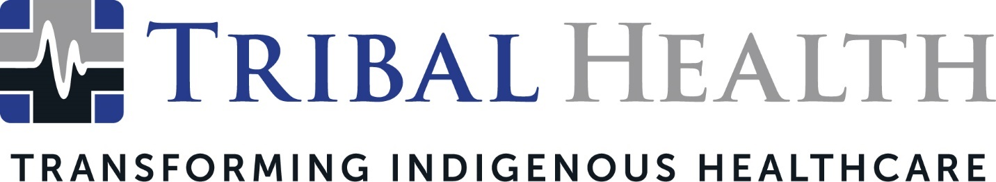

Tribal Health CEO Morgan Haynes Named a Rising Star by Modern Healthcare

SCOTTSDALE, Arizona (April 3, 2024) - Tribal Health, an industry leader in delivering healthcare solutions to Native American communities, announced that its Chief Executive Officer Morgan Haynes was honored as a Rising Star in Modern Healthcare’s Women Leaders in Healthcare program.

Tribal Health President Whittney LaCroix praised Haynes, calling the award a well-deserved validation of her creative thinking, remarkable achievements, and profound passion for improving the patient experience.

“Morgan’s grit and ingenuity have propelled our company to its current position as the leader in Indigenous healthcare transformation,” LaCroix said. “Innovation drives change in healthcare, and Morgan has pushed the envelope on what is possible in the staffing industry, creating programs that spark radical improvements for both healthcare facilities and professionals. Her unique talents exemplify the Tribal Health Way – and this honor is a testament to her vibrant and compassionate brand of leadership.”

Haynes stated that her inclusion on Modern Healthcare’s list of Women Healthcare Leaders was especially meaningful as the award program acknowledges executives who are guiding healthcare delivery improvement across the country. Since taking the helm at Tribal Health, Haynes has led the company through a period of tremendous growth and innovation, expanding the company’s contracts across the country and extending the provision of culturally competent care at Indian Health Services and 638 facilities.

“I am stunned and grateful to be included on a list of such high-achieving women,” Haynes said. “This award is in part a reflection of Tribal Health’s culture, which offers leaders a platform to do incredible work. We emphasize bold thinking and taking risks because we believe that is the best way to overcome the current barriers in our healthcare industry. Our team is diligent in finding new ways of repairing broken systems and tackling the challenges other companies won’t – and this award only fuels our determination to set new standards in healthcare excellence.”

Healthcare providers interested in joining the Tribal Health team can see open positions and career opportunities here.

About Tribal Health
Tribal Health provides emergency medicine, critical care, primary and behavioral health care, as well as consulting and staffing services, to Tribal and federal healthcare facilities nationwide. The only organization of its kind, Tribal Health is committed to transforming Native American and Indigenous communities from within, improving access to care, empowering providers, and delivering high quality, culturally sensitive care that is tailored to Indigenous needs. Learn more at tribalhealth.com.

# # #

Press Contact:
For more information or to arrange an interview, contact vfenyn@tribalhealth.com.

