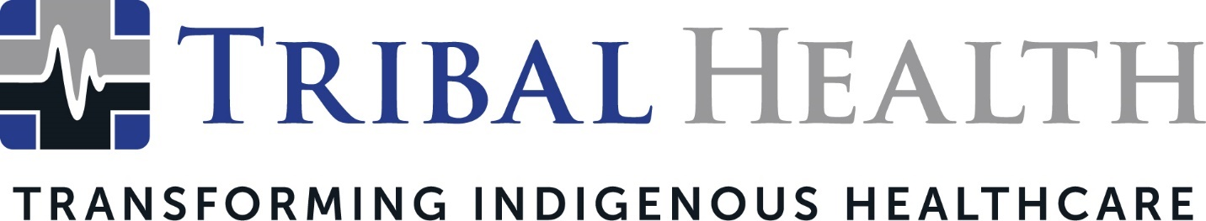

Tribal Health Announces Appointment of Morgan Haynes as New CEO of Tribal Health

SCOTTSDALE, Ariz. (Dec. 12, 2023) - Tribal Health, an industry leader in delivering healthcare solutions to Native communities, announced it has appointed Morgan Haynes, MBA, to the role of Chief Executive Officer. Haynes, renowned for her innovative leadership in the healthcare sector, boasts over a decade of significant contributions to the medical field.
"Morgan’s career is a testament to her commitment to groundbreaking change and compassionate leadership. Her story is truly remarkable," stated John Shufeldt, former CEO of Tribal Health, who will now assume the position of Board Chairman.
Shufeldt added, "Morgan's ascent from healthcare consultant to President and now CEO exemplifies her embodiment of servant leadership and her dedication to empathetic, patient-focused care." He noted that Haynes' impressive 14-year tenure spans private, public, and federal healthcare systems, with an exceptional ability to drive consistent revenue growth that has earned her widespread recognition. Her expertise in staffing and healthcare policy specific to Indigenous healthcare funding and access has been pivotal in positioning Tribal Health as the preferred partner for Indian Health Service and Tribal 638 federal healthcare institutions.
Haynes' leadership has not only resulted in doubling the company's national footprint within a year but also reinforced its advocacy for healthcare reform and its commitment to addressing healthcare inequities.
"At Tribal Health, our goal is to empower our medical professionals to deliver top-notch care to our patients and their families," Haynes said. She added, "Being at the helm during this transformative era in healthcare is exhilarating. Our success stems from addressing challenges that others shy away from, and I intend to maintain this momentum of resilience and innovation."
“Under Morgan's leadership, the outlook for our future is promising,” stated Jedd Rud, Chief Operating Officer at Tribal Health. “Merging time-honored traditions with contemporary medical approaches, Tribal Health is poised to accelerate healthcare transformation within reservation communities. This shift promises increased accessibility to care, improved operational efficiency, and culturally intelligent approaches to the patient experience."

About Tribal Health
Tribal Health provides emergency medicine, critical care, primary and behavioral health care, as well as consulting and staffing services, to Tribal and federal healthcare facilities nationwide. The only organization of its kind, Tribal Health is committed to transforming Native American and Indigenous communities from within, improving access to care, empowering providers, and delivering high quality, culturally sensitive care that is tailored to Indigenous needs. Learn more at tribalhealth.com.

# # #

Press Contact:
For more information or to arrange an interview, contact vfenyn@tribalhealth.com.

