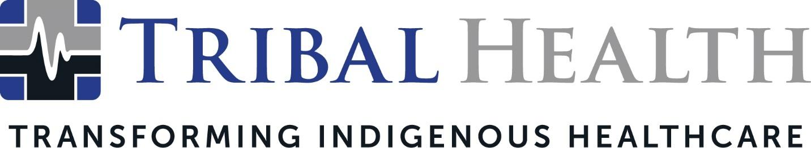

Tribal Health Launches STEM Education Program in Native American Communities
Free digital learning platform intended to increase Native representation in healthcare

SCOTTSDALE, Ariz. (June 13, 2023) – Tribal Health, the leader in healthcare solutions for the underserved, is launching a new STEM (science, technology, engineering, and mathematics) digital education program free of charge for its Native American service communities. The program partners with STEM FUSE, a digital K-12 curriculum provider specializing in STEM, computer science, and CTE curriculum solutions, using their digital learning management system and curriculum delivery platform Educate to help Native American students successfully prepare for STEM careers. Currently Native professionals are underrepresented in STEM fields such as healthcare, engineering, and technology.

In an era where many successful Tribal members are investing in their community’s economic development, increasing Native American representation in STEM can assist with the stewardship of Tribal land, resources, and healthcare. The need for more Native physicians and nurses became especially apparent during the COVID-19 pandemic, which disproportionately impacted Indigenous lands.
“We’re excited to bring an academic launchpad to students in Native communities,” said Tribal Health Chief Nursing Officer Whittney LaCroix (Sicangu Lakota). “Studies show that Native American high school students have less access to STEM coursework than other ethnic groups, which can impact their career opportunities and ultimately Tribal economic development. We’re especially excited to connect more students to healthcare careers, which benefits patient outcomes as well as community health.”
The STEM Fuse all-in-one learning management system (LMS) can be incorporated into existing classroom curriculum through interactive lessons, activities, and assessments. Instructors can assign student work, grade quizzes, and rely on a library of tutorials and teachers’ guides for support. Each student has free access to Career Highways, STEM Fuse’s AI-powered career development and exploration platform that helps them produce a lifetime portfolio to showcase their work and skill sets on their college and internship applications.
“STEM Fuse is proud to join forces with Tribal Health—dedicated to ensuring all students and communities have access to high-quality health science education. Together, we are closing the critical gap of healthcare workers across the U.S., with rural areas most severely affected,” said Carter Tatge, CEO of STEM Fuse. “Tribal Health has created a unique opportunity that allows an expansive and diverse population of aspiring health professionals to learn and succeed in the field of health science. At STEM Fuse, we are driven to make a positive change in our world and are thrilled to have the honor to work alongside Tribal Health."
Dr. Vikram Shankar, Chief Medical Officer, noted the importance of increasing Indigenous representation in medicine.
“Transforming Native American healthcare means changing the system from the inside out – and that means enriching the Indigenous clinical talent pipeline,” said Dr. Shankar. “Native providers can build deeper trust with patients and provide care consistent with their values, beliefs, and cultural traditions. Providing a springboard into STEM education is one way we can increase the number of Native medical students, physicians, and nurses.”
In addition to the STEM Fuse program, Tribal Health offers a free clinical mentorship program for all Native students interested in exploring healthcare careers.

About Tribal Health
Tribal Health provides emergency medicine, critical care, primary and behavioral health care, as well as consulting and staffing services, to Tribal and federal healthcare facilities nationwide. The only organization of its kind, Tribal Health is committed to transforming Native American and Indigenous communities from within, improving access to care, empowering providers, and delivering high quality, culturally sensitive care that is tailored to Indigenous needs. Learn more at tribalhealth.com.

About STEM Fuse
STEM Fuse is a leading K-16 EdTech provider focused on increasing student awareness and readiness for college and careers. STEM Fuse provides students with a platform to plan, prepare and pursue their ongoing education and careers. Headquartered in South Dakota and with a long history of providing educational services to students in the Nationwide, STEM Fuse is committed to helping prepare students for health care and technical careers with a focus on rural awareness and education. Learn more at stemfuse.com

# # #

Press Contact:
For more information or to arrange an interview, contact vfenyn@tribalhealth.com.

