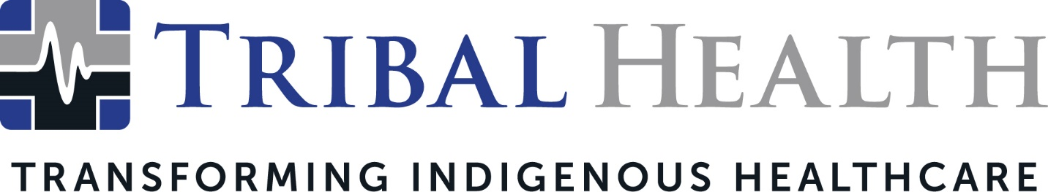

Tribal Health Names Joe Buckley as Vice President of Healthcare Staffing

SCOTTSDALE, Ariz. (May 10, 2023) – Tribal Health, the leader in healthcare consulting and staffing for underserved communities, has named Joe Buckley as Vice President of Healthcare Staffing. In this new role, Buckley will lead Tribal Health’s growth initiatives to meet the ever-increasing need for quality health professionals on Indigenous lands.
Buckley brings more than 25 years of expertise in healthcare staffing to the company’s mission, having led both Fortune 500 companies and startups to talent acquisition success. Recognized for his skills in both recruitment and account management, Buckley has managed strategic planning and business development for the private sector and government facilities, including Indian Health Service, Veterans Administration Medical Center, and the Department of Defense. He is noted for his ability to successfully develop staffing solutions that increase revenue, solve skill gaps, and elevate workforce cultures.
“In his two years with Tribal Health, Joe has distinguished himself through unique growth strategies that yielded critical insights and matured our recruiting program,” said Jed Rudd, Tribal Health Chief Operations Officer. “Healthcare programs on Indigenous lands have unfortunately often been led by outside and disengaged providers – but Joe’s wealth of staffing knowledge has helped us grow a pipeline of quality healthcare professionals committed to transforming Indigenous health. And as a natural technology innovator, he’s created a more efficient staffing experience that frees providers to focus on delivery of care.”
Prior to joining Tribal Health, Buckley gained invaluable expertise in leading high-performing recruiting teams as Vice President of Recruiting for Merritt Hawkins and as Vice President of Physician Recruiting for AMN Healthcare. His goals include the amplification of new talent management programs that can ensure a full complement of staff for each of the company’s new clients.

“Just as the staffing industry is evolving, Tribal Health is growing lightning fast. My goal is to elevate our staffing programs so we can work with the best providers and Indigenous health advocates out there,” said Buckley. “The opportunity to help shape the future of Indigenous healthcare is an immense privilege, and I am honored to play a role in that transformation.”

About Tribal Health
Tribal Health provides emergency medicine, critical care, primary and behavioral health care, as well as consulting and staffing services, to Tribal and federal healthcare facilities nationwide. The only organization of its kind, Tribal Health is committed to transforming Native American and Indigenous communities from within, improving access to care, empowering providers, and delivering high quality, culturally sensitive care that is tailored to Indigenous needs. Learn more at tribalhealth.com.

####

Media Contact:
Please direct all media inquiries to vfenyn@tribalhealth.com.

