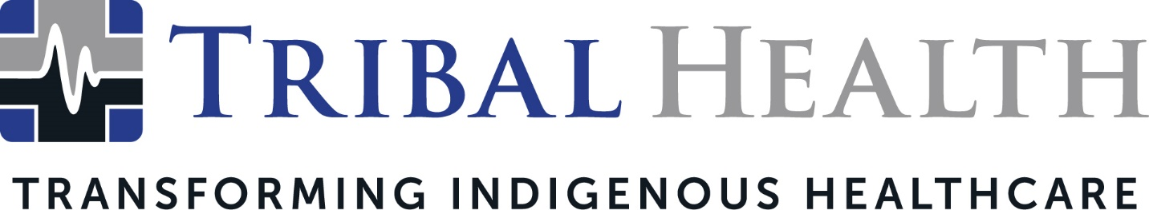

Tribal Health Expands Leadership Team to Accommodate Rapid Growth
New Business Development and Account Management Directors Bring Deep Expertise to Staffing Leader

SCOTTSDALE, Ariz. (April 18, 2023) – Tribal Health, the leader in healthcare staffing and practice management for underserved communities, announced the expansion of its leadership team to better support its swiftly accelerating growth in the Native American and federal healthcare market. The company has named Meredith Humke as Director of Account Management and Joey Foster as Director of Business Development, who together will drive a more responsive and agile experience for the company’s growing client base.

Jed Rudd, Chief Operations Officer, said the two new leaders will play a critical role in the company’s evolving next chapter.

“Meredith is a dynamic and seasoned leader, with a singular ability to help underserved facilities thrive through thoughtful, tailored solutions. Her innovative approach to the client experience aligns with our commitment to reimagining care delivery in underserved areas,” he said. “Joey’s successful track record of connecting Indian Health Service and 638 facilities to our mission over the last five years made him the inevitable choice to head up business development. His wealth of knowledge in this market has fueled dramatic improvements in both facility operations and patient outcomes. We believe their synergy will carry our momentum into a new and exciting era.”

An established client management leader, Humke is recognized for her successful staffing and business development programs across pharmaceutical, senior living, and medical industries. “Building the right relationships is the key to enabling intelligent delivery of care,” she stated. “Knowing Tribal Health’s phenomenal reputation for healthcare transformation, I’m excited to build on their history by identifying new collaborations and solutions for the communities we serve.”

Graduating from Harvard University with a degree in psychology, Joey Foster originally pursued a legal career before moving into business development. As Senior Account Manager with Tribal Health, he played a pivotal role in the company’s recent national growth, which he attributed to the company’s “unique provider-oriented perspectives that guide our decision making.”

“The last year has offered significant power and potential as we’ve expanded our footprint in the Indigenous health space while branching into federal government opportunities,” Foster said. “But our mission to bring quality care to the underserved remains the same – and I’m excited to lead new initiatives that ensure our growth is intentional and aligned with the needs of our communities.”

About Tribal Health
Tribal Health provides emergency medicine, critical care, primary and behavioral health care, as well as consulting and staffing services, to Tribal and federal healthcare facilities nationwide. The only organization of its kind, Tribal Health is committed to transforming Native American and Indigenous communities from within, improving access to care, empowering providers, and delivering high quality, culturally sensitive care that is tailored to Indigenous needs. Learn more at tribalhealth.com.

# # #

Contact:
Please direct media inquiries to vfenyn@tribalhealth.com.

