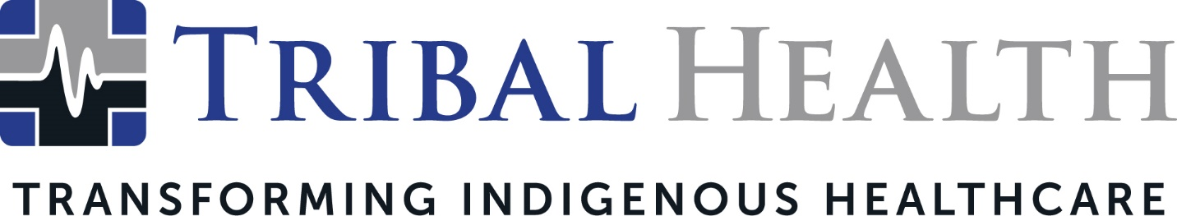

Tribal Health Appoints Dr. Vikram Shankar as New Chief Medical Officer
Emergency Medicine leader brings extensive humanitarian and clinical background to role

SCOTTSDALE, Ariz. (March 31, 2023) – Today, Tribal Health announced the appointment of Dr. Vikram Shankar as the new Chief Medical Officer. In this new role, Dr. Shankar will empower the staffing leader’s network of providers and client facilities through a focus on evidence-based medicine and seamless facility-clinician alignment to deliver the highest standards of patient care.

As Chief Medical Officer, Dr. Shankar contributes years of experience in neurosurgery, trauma surgery, pediatrics, gynecology, anesthesia, general surgery, internal medicine, critical care, cardiology, and point-of-care ultrasound. He currently serves as Co-Medical Director and Emergency Medicine Attending Physician at Pine Ridge and Rosebud IHS Hospitals where he will continue to provide clinical oversight and patient care.
“As a fervent champion of equitable care for all, Dr. Shankar brings a powerful combination of clinical expertise and compassionate leadership to our mission,” said Dr. John Shufeldt, Tribal Health Chief Executive Officer. “From his humanitarian work in West Africa to his leadership in disadvantaged communities across the U.S., Dr. Shankar’s remarkable medical career is distinguished by his commitment to health justice and the patient experience. His ability to combine evidenced-based care with nuanced cultural competency is instrumental during Tribal Health’s accelerating growth.”
Before joining Tribal Health, Dr. Shankar provided medical care for the underserved in Ethiopia and served in the Peace Corps in Togo, West Africa, where he founded Togo Peer Education Health Center, dedicated to addressing malnutrition, malaria, HIV/AIDS, hygiene/sanitation services, and training in nonviolent conflict resolution. During the height of the COVID-19 epidemic, Dr. Shankar volunteered in North Central Bronx Hospital in New York City, where he co-led resuscitation efforts in the ICU, medical floor, and Emergency Department. He also provided Allied United for Health with educational health services to low-income communities in Madison, WI.

“In his years as Medical Director, Dr. Shankar continually impressed us with his gift for addressing the unique biopsychosocial challenges in Indigenous health,” said Morgan Haynes, President. “Not only has he delivered irreplaceable, hands-on leadership in training and mentoring providers, his international experience in solving health disparities has endowed him with the insight to reimagine solutions for even entrenched health disparities. Naming him Chief Medical Officer was the inevitable choice as we expand our clinical footprint in new regions and new underrepresented populations.”

Dr. Shankar expressed his enthusiasm for the next chapter of Tribal Health’s mission, stating he looked forward to expanding the company’s focus on industry guidelines, process improvements, and community relationships.

“I joined Tribal Health because the company is unique in its three-fold commitment to patients, providers, and communities,” Dr. Shankar said. “Delivering on our promise of that support ultimately translates to better patient outcomes for Indigenous patients and thriving Indigenous communities. I’m honored to be at the helm of such an incredible opportunity.”

Dr. Shankar is a member of American College of Emergency Physicians, American Academy of Emergency Medicine Society, and Academic Emergency Medicine American Medical Association. He earned a Bachelor of Arts in Urban and Environmental Policy, Occidental College, CA, and a Doctor of Medicine, from University of Wisconsin, School of Medicine and Public Health. He completed his Emergency Medicine Residency at University of California Los Angeles (UCLA) – Kern Medical. He is currently earning a Master of Business Administration from Johns Hopkins University.

About Tribal Health
Tribal Health provides emergency medicine, critical care, primary and behavioral health care, as well as consulting and staffing services, to Tribal and federal healthcare facilities nationwide. The only organization of its kind, Tribal Health is committed to transforming Native American and Indigenous communities from within, improving access to care, empowering providers, and delivering high quality, culturally sensitive care tailored to Indigenous needs. Learn more at tribalhealth.com.

# # #

Media Contact:
Please direct all media inquiries to vfenyn@tribalhealth.com.

