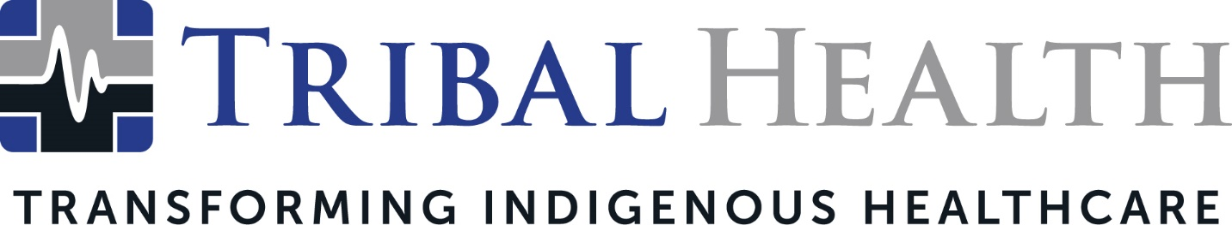

Tribal Health Launches Behavioral Health Services for Indigenous Communities
New healthcare programs address mental health and substance abuse crisis in Indian Country

SCOTTSDALE, Ariz. (October 26, 2022) – Tribal Health, the leader in Indigenous healthcare consulting and staffing, announced it is launching a new arm of behavioral health programs for Indian Health Service (IHS) and other federal healthcare facilities, as well as Tribally operated clinics. By partnering culturally informed care with clinical expertise in mental illness and substance abuse treatment, Tribal Behavioral Health aims to address the shortage of behavioral health resources in Tribal communities.

In addition to providing a full range of treatment and recovery services, such as medication-assisted treatment (MAT) programming and intensive outpatient programs (IOP), Tribal Behavioral Health offers wraparound services and long-term recovery groups to support patients at every step of their mental health journey.

“Treating behavioral health needs is the next phase in fulfilling our mission of building stronger, healthier Tribal communities,” said Tribal Health Chief Operations Officer Jed Rudd. “By bringing world-class providers and national standards of care to Tribal facilities, we’ve been able to help transform the Indigenous healthcare experience. Partnering with Native American communities to collaboratively design culturally centered approaches to behavioral healthcare is another way we can support the revitalization of Tribal nations.”

Tribal Behavioral Health customizes behavioral health solutions to each facility’s needs, expanding current services or designing new clinical programs as needed. In addition to providing psychiatrists and other trained clinicians, the company works with architectural partners to build new clinical facilities and patient housing structures.

Behavioral Health Director Denny Haag witnessed firsthand the urgent need for culturally intelligent behavioral services in Indian Country when he previously led an Indian Health Service facility. According to Haag, many Indigenous patients experience discrimination in non-Native clinical environments but cannot find behavioral health programs in their own communities.

“By combining mental health expertise with traditional Indigenous therapies, Tribal Behavioral Health can help unlock long-term transformation on a personal and community level,” Haag said. “We partner with our clients to learn their strategies and vision, then facilitate and contribute the resources needed for Tribal programs to succeed. From supplying quality staff to building community-based healing centers, we tailor all programs to ensure Indigenous patients receive effective and respectful behavioral care.”

Tribal Health provides integrated primary, specialty, and emergency care for Indigenous patients. The company was recently named the 2022 U.S. Department of Health and Human Services’ Small Business Prime Contractor of the Year.

About Tribal Health
Tribal Health provides emergency medicine, critical care, primary and behavioral health care, as well as consulting and staffing services, to Tribal and federal healthcare facilities nationwide. The only organization of its kind, Tribal Health is committed to transforming Native American and Indigenous communities from within, improving access to care, empowering providers, and delivering high quality, culturally sensitive care that is tailored to Indigenous needs. Learn more at tribalhealth.com.

# # #

Press Contact:
Please direct media inquiries to vfenyn@tribalhealth.com.

