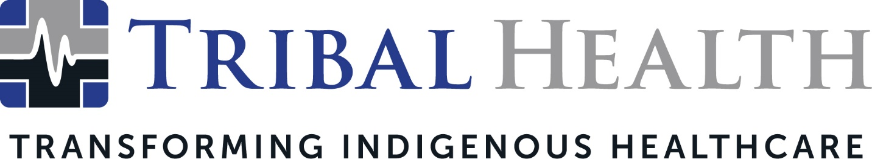

Tribal Health Awarded Health Care Staffing Services Certification from The Joint Commission

SCOTTSDALE, Ariz. (July 7, 2022) – Tribal Health, the leader in healthcare consulting and staffing for Indigenous communities, has earned The Joint Commission’s Gold Seal of Approval® for Health Care Staffing Services Certification by demonstrating continuous compliance with its performance standards. The Gold Seal is a symbol of quality healthcare that reflects Tribal Health’s commitment to providing exceptional patient care.

Tribal Health connects underserved Tribal and IHS facilities to culturally intelligent medical expertise and high-quality healthcare models. The Health Care Staffing Services Certification demonstrates Tribal Health’s success in determining staff qualifications and competencies, staff placement, and the monitoring of staff performance.

The Joint Commission evaluated Tribal Health’s compliance with related certification standards through a rigorous review on May 17, 2022. Those standards included Leadership, Human Resources Management, Performance Measure and Improvement, and Information Management. Joint Commission standards are developed in consultation with health care experts and providers, measurement experts, and patients.

“Health Care Staffing Services Certification recognizes health care staffing firms committed to fostering continuous quality improvement in patient safety and quality of care,” says Mark Pelletier, RN, MS, chief operating officer, Accreditation and Certification Operations, and chief nursing executive, The Joint Commission. “We commend Tribal Health for using certification to strengthen its program structure and management framework, as well as to enhance its staff recruitment and development processes.”

Whittney LaCroix, Tribal Health Chief Nursing Officer, said the certification reflected the company’s dedication to helping Tribal and IHS facilities fulfill their vision of sustainable healthcare change.

“We’re honored and excited to receive The Joint Commission’s Healthcare Staffing Services Certification,” said LaCroix. “This reaffirms our efforts to support Indigenous healthcare by connecting Indian Country to talented, high-caliber healthcare professionals and exceptional patient services. Facilities that work with Tribal Health can look to this certification as an assurance that we are passionate about patient safety and quality improvements.”

Tribal Health President Morgan Haynes noted the certification reflected the high quality of the company’s clinical operations. “Achieving HCSS Certification demonstrates Tribal Health’s ongoing commitment to the exceptional standard of service we bring to every client,” said Haynes. “The Joint Commission identified no areas for improvement, which meant we had zero findings – a testament to the hard work and meticulous preparation our team is known for. We look forward to a future of even stronger clinical innovations for healthcare facilities in Tribal nations.”

About Tribal Health
Tribal Health provides emergency medicine, critical care, primary and behavioral health care, as well as consulting and staffing services, to Tribal and federal healthcare facilities nationwide. The only organization of its kind, Tribal Health is committed to transforming Native American and Indigenous communities from within, improving access to care, empowering providers, and delivering high quality, culturally sensitive care that is tailored to Indigenous needs. Learn more at tribalhealth.com.

# # #

Press Contact:
Please direct media inquiries to vfenyn@tribalhealth.com.

