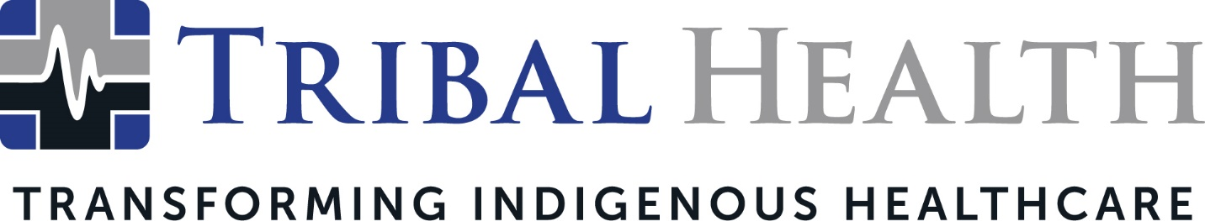

Tribal Health Receives the Small Business Prime Contractor of the Year Award from U.S Department of Health and Human Services, Office of Small and Disadvantaged Business Utilization

SCOTTSDALE, Ariz. (May 19, 2022) – Tribal Health, the leader in healthcare consulting and staffing for Indigenous communities, has been named the 2022 recipient of the Office of Small and Disadvantaged Business Utilization (OSDBU), Small Business Prime Contractor of the Year Award from the U.S. Department of Health and Human Services (HHS). The award recognizes Tribal Health’s dedication and commitment to the HHS Small Business Program in transforming patient outcomes in Indian Health Service (IHS) and 638 facilities in Tribal nations.

HHS recognized Tribal Health during the 2022 Small Business National Virtual Conference, at the OSDBU Excellence Awards Ceremony. The award honors a small business that has excelled during the previous fiscal year in the performance of an HHS contract.
“We are thrilled and honored to receive such prestigious recognition from HHS,” said Jed Rudd, Tribal Health Chief Operations Officer. “Our goal has always been to not only elevate patient care, but to drive a profound and lasting impact by bringing resiliency to healthcare ecosystems in Indian Country. The opportunity to work with IHS facilities is a privilege – and this award is a true testament to the success of our collaboration.”
Tribal Health connects underserved Tribal and IHS facilities to culturally sensitive medical expertise and high-quality healthcare models. During the pandemic, the company supplemented its culture-centric approach with Critical Care Response Training (CCRT) deployments, which helped facility staff gain new competencies through elbow-to-elbow instruction and virtual simulations, increasing the quality of care in Tribal nations. Other key initiatives included the creation of additional emergency departments to minimize COVID infections patients, mobile vaccine units, new stroke treatment programs, and clinician training on sex trafficking and intimate partner violence.
Morgan Haynes, Tribal Health President, said the award reflected the company’s commitment to transforming the healthcare experience for both patients and clinical staff.
“We are so profoundly grateful to be recognized by HHS," said Haynes. “Our mission is to accelerate sustainable healthcare change in Indian Country – but change is a collaborative effort and we feel lucky to work with such forward-thinking IHS and Tribal facilities. The Tribal Health story is one of grit, passion, and community spirit, and this award inspires us to reach even higher heights of care transformation.”
Whittney LaCroix, Chief Nursing Officer, credited front-line healthcare staff for their ability to pair clinical excellence with tireless compassion. “One of our founding principles is the delivery of the highest levels of culturally intelligent care for our communities,” she said. “This kind of recognition is even more momentum toward our ultimate goal – a world where health equity is a reality.”

About Tribal Health
Tribal Health provides emergency medicine, critical care, primary and behavioral health care, as well as consulting and staffing services, to Tribal and federal healthcare facilities nationwide. The only organization of its kind, Tribal Health is committed to transforming Native American and Indigenous communities from within, improving access to care, empowering providers, and delivering high quality, culturally sensitive care that is tailored to Indigenous needs. Learn more at tribalhealth.com.

# # #

Press Contact:
Please direct media inquiries to vfenyn@tribalhealth.com.

