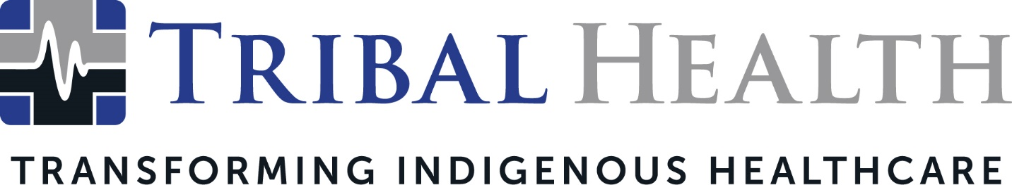

New Tribal Health Podcast Explores Indigenous Healthcare, Wellbeing, and Culture

SCOTTSDALE, Ariz. (March 28, 2022) – Tribal Health, the leader in healthcare consulting and staffing for Indigenous communities, today announced the launch of the Tribal Health Podcast. Pairing healthcare expertise and engaging storytelling, the podcast will offer insightful conversations on Native American healthcare, wellbeing, and culture. The first episode will air March 31 on Spotify and Apple.

Co-host Melody Lewis, Mojave/Tewa/Hopi and an enrolled member of the Fort Mojave Indian Tribe, said the bi-weekly podcast will explore the topics that shape modern Indigenous lives, such as culture-centric care, addiction and mental health, chronic conditions in Tribal nations, women’s health, and the legacy of the forced boarding school era. Listeners will learn techniques for navigating Indigenous healthcare systems as patients and providers, as well as practices that can transform Native American communities.

“Our goal with the Tribal Health Podcast is to give listeners in-depth conversations on the most pressing issues in Indian Country,” said Lewis. “After a long history of injustice toward Native Americans in healthcare and government, we’re seeing a seismic cultural shift take place where non-Native people want to understand the Indigenous perspective. At the same time, Indigenous people are exploring their identities and reviving traditional ancestral practices that have been lost to cultural erasure. The podcast will provide a fresh and nuanced perspective that speaks to both Native and non-Native audiences.”

The Tribal Health Podcast’s three co-hosts bring different perspectives from their work in the Indigenous healthcare space. Melody Lewis is a social entrepreneur and expert in workforce development and diversity, equity, and inclusion (DEI) initiatives, using collaborative approaches rooted in Indigenous identity. Morgan Hayes, President of Tribal Health, is a healthcare advocate for the underserved who is recognized for her ability to solve Indigenous care disparities with sustainable business initiatives. Mario Trujillo, a cultural influencer and communications consultant, specializes in using multi-media storytelling to build positive social, community, and economic alliances.

“This is a necessary and long overdue expansion in the conversation about Indigenous health and wellbeing,” said Haynes. “We believe that knowledge drives change – and that real-world stories have the power to build life-changing connections. Our incredible line-up of guests includes leaders at the top of the fields who aren’t afraid to explore hot-button topics. We can’t wait to take our listeners on what we know will be a fascinating journey.”

All podcast episodes will be available at Spotify and Apple.

About Tribal Health
Tribal Health provides emergency medicine, critical care, primary and behavioral health care, as well as consulting and staffing services, to Tribal and federal healthcare facilities nationwide. The only organization of its kind, Tribal Health is committed to transforming Native American and Indigenous communities from within, improving access to care, empowering providers, and delivering high quality, culturally sensitive care that is tailored to Indigenous needs. Learn more at tribalhealth.com.

# # #

Press Contact:
Please direct media inquiries to vfenyn@tribalhealth.com.

