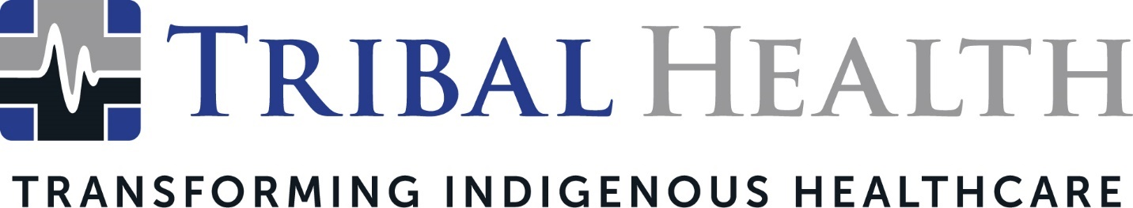

Whittney LaCroix, Indigenous Healthcare Leader, Joins Tribal Health as New Chief Nursing Officer

SCOTTSDALE, Ariz. (Dec. 15, 2021) – Tribal Health, the leader in healthcare consulting and staffing for Native American communities, has named Whittney LaCroix (Sicangu Lakota) as Chief Nursing Officer. Recognized for her clinical versatility and groundbreaking leadership in Indian Health Service and Tribal healthcare facilities, LaCroix will lead all nursing operations in support of Tribal Health’s mission of transforming Indigenous healthcare.

Tribal Health Chief Executive Officer Dr. John Shufeldt stated that LaCroix’s reputation as a patient-focused visionary made her an exciting addition to the Tribal Health leadership team.

“We believe Native American leadership is critical when it comes to solving healthcare disparities in Tribal nations,” said Shufeldt. “Whittney’s wealth of expertise in addressing Indigenous health challenges is matched only by her gift for developing incisive clinical solutions. She is a courageous, passionate leader dedicated to the communities she serves – and she has already played a transformative role in reinventing the face of Indigenous healthcare.”

Tribal Health DEI Director Melody Lewis added, “Representation matters – and as an Indigenous woman, seeing a fellow sister shatter entrenched barriers is so empowering. Whittney is a healthcare trailblazer and she brings both clinical excellence and her lived experiences to support her community. It’s so powerful to watch her change healthcare and inspire the next Indigenous generation to pursue that kind of achievement at the same time.”

LaCroix previously served as Deputy Chief Executive Officer at Rosebud Indian Health Service (IHS) Unit and Director of Nursing of the White River Health Care Center, where she led efforts that earned a 5-star quality rating by the Centers for Medicaid and Medicare Services (CMS) and a zero-deficiency survey from the South Dakota Department of Health. She has developed clinical programs for Native American communities across a variety of disciplines, including emergency medicine, pediatrics, obstetrics, elder care, and long-term care.

“Whittney is a tenacious change agent with a heart of gold – and that’s what makes her ability to support IHS and 638 facilities so powerful,” said Tribal Health President Morgan Haynes. “For years, Tribal Health has had the privilege of witnessing her heartfelt dedication to strengthening Native American communities. We couldn’t be more excited to have her lead our nursing team into a strong and successful future.”

As Tribal Health Chief Nursing Officer, LaCroix aims to expand clinical and cultural knowledge in the service of addressing health disparities in Tribal nations.

“My goal is to support Native American healthcare and self-determination through intelligent collaboration with IHS and 638 facilities,” LaCroix said. “This is more than a career to me because it’s part of who I am and where I come from. By joining a team known for innovative delivery models and culturally sensitive care, I hope to connect more Indigenous communities to sophisticated medical expertise and more Native Americans to healthier futures.”

About Tribal Health
Tribal Health provides emergency medicine, critical care, primary and behavioral health care, as well as consulting and staffing services, to Tribal and federal healthcare facilities nationwide. The only organization of its kind, Tribal Health is committed to transforming Native American and Indigenous communities from within, improving access to care, empowering providers, and delivering high quality, culturally sensitive care that is tailored to Indigenous needs. Learn more at tribalhealth.com.

# # #

Press Contact:
Please direct media inquiries to vfenyn@tribalhealth.com.

