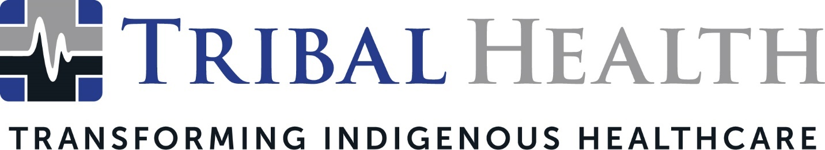

Tribal Health Partners with Arizona Coyotes and Indigenous Leaders in Holiday Toy Drive

SCOTTSDALE, Ariz. (Nov. 30, 2021) – Tribal Health, the leader in healthcare consulting and staffing for Native American communities, is launching a toy drive in partnership with the Arizona Coyotes, Cahokia SocialTech + ArtSpace, and other Indigenous businesses. The Coyotes at Cahokia Christmas Toy Drive will provide toys, books, and clothing to help give Native American children in need a special and memorable holiday season.

The drive kicks off Dec. 3 with a First Friday event at Cahokia that features the Arizona Coyotes. In addition to donation sites across the Valley, fans and friends can participate by bringing unwrapped toys to the Coyotes’ Dec. 15 home game against the New York Rangers at Gila River Arena.

“We’re thrilled to partner with the Coyotes and Cahokia to give children a magical Christmas,” said Tribal Health President Morgan Haynes. “This is the perfect time of year to deliver joy and abundance to our communities, especially in a year when so many families are struggling. We all remember how exciting it was to unwrap special toys on Christmas morning as children – and we want to ensure every child in need experiences that same excitement and sense of wonder. Our goal is to help families create holiday memories that last a lifetime.”

New and unwrapped toys and clothes can be dropped off at donation sites from December 3 through December 20. Those who prefer to participate virtually can purchase items through online stores or send Amazon gift cards. All items will be distributed to families in Indigenous communities. Donors are encouraged to remember children over the age of 13, as this age group typically receives the lowest number of gifts.

Melody Lewis, founder of Indigenous Community Collaborative and Cahokia SocialTech + ArtSpace, said the partnership was an inspiring opportunity to connect non-Native organizations to Tribal nations. “When Indigenous-led spaces align our cultural knowledge with the season of giving, we can empower Native American communities in a meaningful way,” she said. “The Coyotes’ generosity goes beyond helping Indigenous children feel cherished and special – it helps us amplify Indigenous voices and find new ways to strengthen our communities.”

Drop Off Locations:
Cahokia: 707 North 3rd Street, Phoenix, AZ 85004
Tribal Health: 14614 N. Kierland Blvd., Suite 120, Scottsdale, AZ 85254
All sites are open 10:00 am – 4:00 pm, Monday – Friday. Amazon gift cards can be sent to info@cahokia.com.

About Tribal Health
Tribal Health provides emergency medicine, critical care, primary and behavioral health care, as well as consulting and staffing services, to Tribal and federal healthcare facilities nationwide. The only organization of its kind, Tribal Health is committed to transforming Native American and Indigenous communities from within, improving access to care, empowering providers, and delivering high quality, culturally sensitive care that is tailored to Indigenous needs. Learn more at tribalhealth.com.

# # #

Press Contact:
For more information or to arrange an interview, contact vfenyn@tribalhealth.com.

