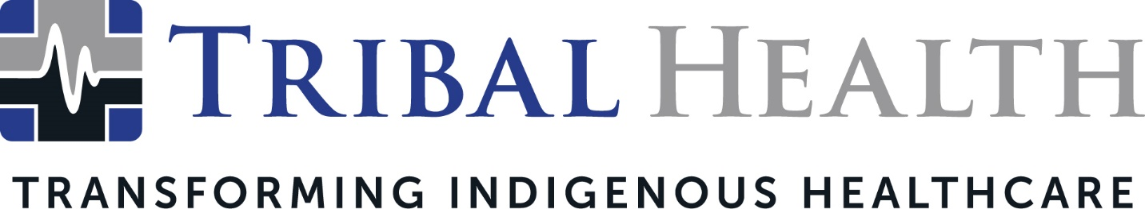

Tribal Health Named a Best Place to Work in the Valley by Phoenix Business Journal
Leader in Indigenous healthcare staffing recognized for supportive culture, meaningful career opportunities

SCOTTSDALE, Ariz. (Nov. 18, 2021) – Tribal Health, the leader in healthcare consulting and staffing for Native American communities, announced it has been named as one of Phoenix’s Best Places to Work by the Phoenix Business Journal. Winners are selected based on confidential surveys, which ask employees to rank their organization in areas such as leadership, values, compensation, collaboration, and career opportunities.
Tribal Health President Morgan Haynes said the company strives to foster an empowering company culture to ensure high performance in its mission of transforming Indigenous healthcare.
“Our goal is to help our employees build the career of their dreams while empowering them to change healthcare disparities on a generational scale. This recognition confirms we are on the right path,” said Haynes. “We believe that giving today’s best and brightest professionals the opportunity to do meaningful work is a win for everyone. To that end, we strive to create an exceptional employee experience that gives them a platform to do their best work.”
Tribal Health recently expanded from Tribal EM, after significant growth and the launch of new vertical lines. To ensure its culture is vibrant, fair, and supportive of all employees, the company recently launched a robust Diversity, Equity, and Inclusion program that has earned high marks with its fast-growing workforce.
“Being included on the Best Places to Work List with so many admirable companies in the running is an incredible honor,” said Dr. John Shufeldt, Tribal Health CEO. “We believe that building an inclusive and creative workplace leads to high motivation and extraordinary success. I am overwhelmingly grateful to each member of our team, because it’s their passion and thoughtfulness that make our culture so enjoyable.”
Tribal Health and other winners will be honored at the awards luncheon at the JW Marriott Phoenix Desert Ridge Resort & Spa on Dec.16. Winner profiles will be featured in the Phoenix Business Journal's Best Places to Work special edition on Dec. 17.
About Tribal Health
Tribal Health provides emergency medicine, critical care, primary and behavioral health care, as well as consulting and staffing services, to Tribal and federal healthcare facilities nationwide. The only organization of its kind, Tribal Health is committed to transforming Native American and Indigenous communities from within, improving access to care, empowering providers, and delivering high quality, culturally sensitive care that is tailored to Indigenous needs. Learn more at tribalhealth.com.

# # #

Press Contact:
Please direct media inquiries to vfenyn@tribalhealth.com.

