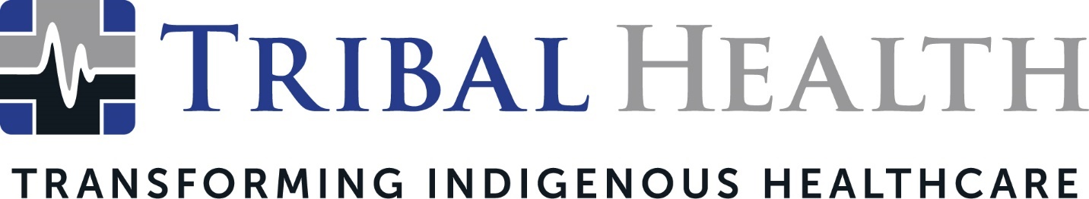

Tribal EM Expands as Tribal Health, Announces New Behavioral Health Company for Indigenous Communities
Rising demand for consulting, medical and behavioral care in Native American communities drives Tribal healthcare leader’s growth

SCOTTSDALE, Ariz. (Sept. 21, 2021) – Tribal EM, the leader in healthcare consulting and staffing for Native American communities, announced its expansion in response to rapid company growth and accelerating demand for services. The company has rebranded as Tribal Health, an evolution that represents its advanced new service offerings in transforming Indigenous healthcare. Founder and CEO John Shufeldt will also launch another company, Tribal Behavioral Health, later this year. Tribal Behavioral Health will support Tribal facilities’ efforts to address rising rates of substance abuse, overdose, mental illness, and suicide.
Since its inception six years ago, Tribal Health has progressively earned a reputation for revolutionizing the Native American healthcare experience, thanks to its unique offering of pairing top-tier medical talent with culturally informed care for Indigenous communities. The company experienced 43% growth last year, quadrupling its national presence and adding dozens of specialties to its clinical roster. Recently Tribal Health was named the 2021 recipient of the Making a Difference award from Women in Healthcare.
“Becoming Tribal Health better represents our full suite of consulting, staffing, and care delivery capabilities,” said Dr. John Shufeldt, Chief Executive Officer. “After initially specializing in emergency medicine, our reputation quickly grew across the Tribal healthcare space – and facilities began asking us to provide a wide range of medical and behavioral care and onsite training. The name ‘Tribal EM’ no longer describes our versatile clinical, staffing, and consulting offerings.”
Tribal Health has three divisions known as:
- Tribal Consulting: The suite of consulting services includes CMS and Joint Commission survey preparedness, Six Sigma-driven performance improvement credentialing processes, policy and procedure review and implementation, and facility design and construction.
- Tribal Emergency Medicine: Highly specialized emergency medicine and critical care providers will continue to provide advanced medical expertise and clinical versatility tailored to the challenges of Indian Health Service and 638 facilities. This includes the company’s in-demand Critical Care Response Team (CCRT) program, which provides rapid deployments to train facility staff in critical care and COVID-19 protocols.
- Tribal Pro Staffing: Tribal Health’s locum tenens arm continues to focus on closing Tribal healthcare gaps through advanced clinical expertise, culture-centric care, and systemic improvements to delivery of care. Tribal Pro Staffing is currently in 15 states with two dozen specialties – and growing.
Tribal Behavioral Health will pair clinical expertise with traditional Indigenous therapies in integrated primary, emergency, and behavioral care. The company will offer a full spectrum of services - from primary mental health to detox and residential services to outpatient programs, reintegration pathways, and Medically Assisted Treatment (MAT) programming. Tribal Behavioral Health will also mirror Tribal Health’s recruitment efforts within Native American communities to enrich the Indigenous healthcare talent pipeline.
Healthcare facilities can request any combination of services. All Tribal Health divisions will continue to offer world-class providers and consultants trained in Native American cultural and community nuances.
“Our new identity better aligns our expertise with the healthcare needs in Tribal communities,” said Morgan Haynes, Chief Operations Officer. “Our mission to transform Indigenous health on individual, community and generational levels remains the same. Our expansion strengthens our ability to help solve those healthcare disparities. We’re excited and grateful for the opportunity to partner with Tribal and Indian Health Service facilities in new and innovative ways.”

About Tribal Health
Tribal Health provides emergency, primary, and behavioral care, as well as consulting and staffing services to Tribal and federal healthcare facilities nationwide. The only organization of its kind, Tribal Health is committed to transforming Native American and Indigenous communities from within, improving access to care, empowering providers, and delivering high quality, culturally sensitive care that is tailored to Indigenous needs. Learn more at tribalhealth.com.

# # #

Contact:
Valerie Fenyn
Tribal EM
(602) 206-4847
vfenyn@tribalhealth.com

