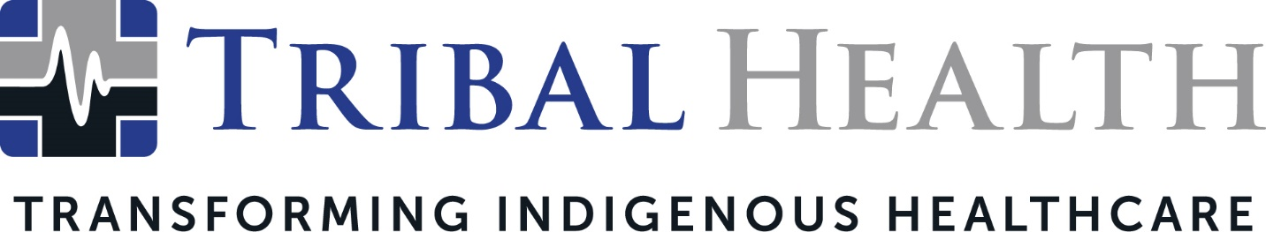

Tribal Health Announces Promotion of Morgan Haynes to President
Healthcare leader committed to transforming Indigenous communities

SCOTTSDALE, Ariz. (Sept. 27, 2021) – Tribal Health, the leader in healthcare management, staffing, and consulting for Indigenous and federal health systems, today announced the promotion of Morgan Haynes from Chief Operations Officer to President. Haynes joined Tribal Health in 2016 to oversee business development, operations, and federal contracting. While serving as Chief Operations Officer, she led the company to consistent year-over-year revenue growth while significantly impacting its national presence.
Originally launched as an emergency medicine practice management, staffing and consulting company, today Tribal Health provides multispecialty support through emergency medicine, outpatient, behavioral health, primary, and critical care for Indigenous communities, as well as providing specialists in all clinical disciplines. To address the urgent mental health crisis in Indian Country, the company is splitting its behavioral healthcare offerings into a new company, Tribal Behavioral Health.
Chief Executive Officer Dr. John Shufeldt noted Haynes’ operational expertise in private, public, and federal healthcare systems has played an integral and pivotal role in Tribal Health’s rapid success. Haynes also launched the company’s highly successful Critical Care Response Deployment program, which has helped increase both COVID-19 survival rates and Tribal facility performance across the country.
"During her time with Tribal, Morgan's energy and insight have been invaluable to driving both our national expansion and our inspiring company culture," said Dr. Shufeldt. "As President, she can focus her tenacity and gift for professional development to build stronger bridges between Native American communities and our outstanding provider network. I look forward to the intensified impact she will continue to make in our mission to transform Indigenous healthcare.”
Tribal Health will remain clinically led, with Dr. Shufeldt as CEO. Haynes stated her personal mission is to continue the company’s expansion in a meaningful way through new culturally conscious offerings.
“Joining Tribal Health made my dream of making a meaningful impact in healthcare come true. It’s been an honor to work toward our mission, and see it come to fruition and gain momentum,” Haynes said. “Taking on a bigger leadership role will allow me to spend more time connecting with Tribal leaders and working directly with the communities we serve. There’s an exciting and overdue revitalization happening in Native American healthcare right now, and we’re honored to contribute to it in any way we can."

Haynes also serves as advisor for healthcare consultancy Shufeldt Consulting and Tribal Behavioral Health. In addition, she acted as advisor for telemedicine leader MeMD until its acquisition by Walmart.

About Tribal Health
Tribal Health provides emergency medicine, critical care, specialty, primary and behavioral health care as well as consulting and staffing services to Tribal and federal healthcare facilities nationwide. The only organization of its kind, Tribal Health is committed to transforming Native American and Indigenous communities from within, improving access to care, creating health care career opportunities, empowering providers, and delivering high quality, culturally sensitive care that is tailored to Indigenous needs. Learn more at tribalhealth.com.

