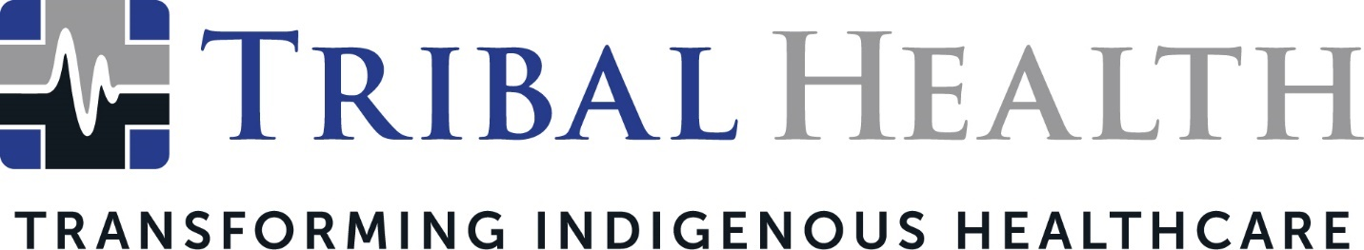

Tribal Health Wins the Making a Difference Award from Women in Healthcare
Leader in Indigenous healthcare consulting and staffing recognized for contributions to Native American communities

SCOTTSDALE, Ariz. (Oct. 20, 2021) – Tribal Health, the leader in healthcare consulting and staffing for Native American communities, announced it has been named the recipient of the 2021 Making a Difference award from Women in Healthcare. The Making a Difference Award honors a company who is making significant contributions to their community through their time, actions, talents, and dedication. The honoree is intended to serve as a role model to other organizations in the areas of compassion and service.

Morgan Haynes, Tribal Health President, said the company was thrilled to be recognized by Women in Healthcare, which promotes growth and networking for female healthcare professionals.

“Receiving this award is an emotional experience and a humbling one,” Haynes said. “In a year when the pandemic has exacerbated the need for medical expertise in Indigenous communities, we’ve been inspired by our staff’s ingenuity and exhaustive efforts to build resiliency in Tribal facilities. From new emergency departments to mobile vaccine units, they’ve helped create a healthier tomorrow for some of our most vulnerable patients. This recognition from Women in Healthcare is incredibly gratifying – and it strengthens our mission of transforming Native American communities through culturally sensitive care.”

Tribal Health’s focus on revolutionizing the Indigenous healthcare experience intensified during the COVID-19 pandemic. The company created a Critical Care Response Team (CCRT) deployment program, sending faculty from top medical schools to Indian Health Service (IHS) and federal healthcare facilities to train their staff in critical care protocols. Because many of these facilities are located in isolated areas, it is difficult for staff to find accessible instruction in the advanced procedures required to care for patients infected with the SARS-CoV-2 virus. The CCRT program has helped boost COVID-19 survival rates, reduce patient transfers, and permanently transform facility performance.

“It is a true honor for our team to have their efforts recognized,” said Jed Rudd, Chief Operations Officer. “Every day they bring their passion, courage, and commitment to deliver exceptional patient care in challenging environments. This pandemic has impacted Indigenous communities to a gruesome extent, and we’re determined to foster long-term healthcare transformation in any way we can.”

Tribal Health recently expanded in response to accelerating demand for services. Founder and CEO Dr. John Shufeldt will also launch another company, Tribal Behavioral Health, later this year. Tribal Behavioral Health will support Tribal facilities’ efforts to address rising rates of substance abuse, overdose, mental illness, and suicide.

Tribal Health will be honored at the Women in Healthcare Summit award ceremony on Thursday, October 21, 2021, in Baltimore, MD.

About Tribal Health
Tribal Health provides emergency medicine, critical care, primary and behavioral health care, as well as consulting and staffing services, to Tribal and federal healthcare facilities nationwide. The only organization of its kind, Tribal Health is committed to transforming Native American and Indigenous communities from within, improving access to care, empowering providers, and delivering high quality, culturally sensitive care that is tailored to Indigenous needs. Learn more at tribalhealth.com.

# # #

Contact:
Valerie Fenyn
Tribal Health
(602) 206-4847
vfenyn@tribalhealth.com

