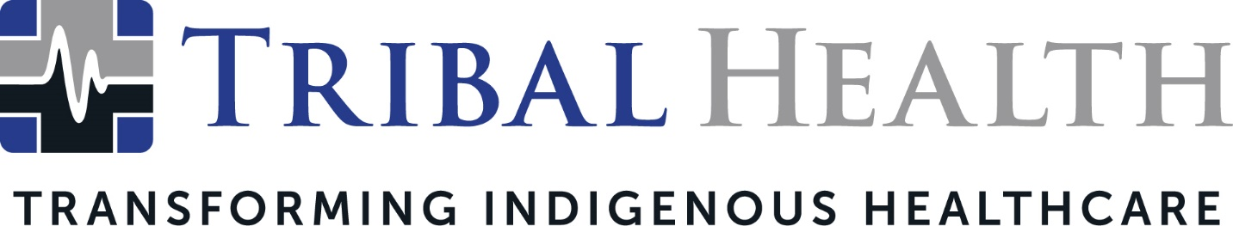

Tribal Health Names Jed Rudd as New Chief Operations Officer
Healthcare Trailblazer Joins Indigenous Consulting and Staffing Leader

SCOTTSDALE, Ariz. (Oct. 28, 2021) – Tribal Health, the leader in healthcare consulting and staffing for Native American communities, has named Jed Rudd as Chief Operations Officer. With an extensive background in both clinical practice and executive leadership, Rudd has served at the helm of several Tribal and private healthcare organizations. His arrival accompanies Tribal Health’s recent geographic and service line expansion.

The Chief Operations Officer role was vacated this autumn when Morgan Haynes was promoted to President. Prior to this appointment, Rudd was responsible for leading the overarching strategy and execution for United Indian Health Services. In that role, he achieved significant gains in programmatic expansion, process improvement, quality assurance, and operational performance.

“Jed is a dynamic and seasoned leader, with an unparalleled ability to align clinical excellence with industry-leading operational practices,” said Dr. John Shufeldt, Tribal Health Chief Executive Officer. “His unique gift for building vibrant workplace cultures while refining both the patient and clinician experience positions him as the perfect leader to drive the next era of Tribal Health’s growth. I look forward to the new ideas, depth, and energy he’ll bring to our organization.”

A passionate advocate for Indigenous healthcare, Rudd stated he was inspired to join Tribal Health after working with the company on systemic improvements to United Indian Health Services facilities.

“Having led multiple multi-facility healthcare organizations, I’m excited now for the opportunity to drive that transformation on a national scale,” said Rudd. “Tribal Health has been growing in leaps and bounds, which unlocks new ways we can import expert healthcare to Tribal communities. By expanding our operational efficiency, my goal is to ensure we deliver exceptional care today while creating sustainable change that continues beyond tomorrow.”
Tribal Health recently rebranded from its original inception as Tribal EM, expanding its focus on emergency medicine to include family, specialty, and behavioral care, as well as consulting services. The company’s ability to pair culturally sensitive healthcare with advanced critical care expertise sparked high demand during the COVID-19 pandemic.

“Tribal Health's future has never been more compelling, and we knew Jed was the right person to capitalize on our momentum and lead operations to even greater heights,” said Morgan Haynes, Tribal Health President. “His experience ensures an operational sophistication that can only enhance the quality of our services. We’re so excited the timing and relationship came together to further energize our leadership team.”

About Tribal Health
Tribal Health provides emergency medicine, critical care, primary and behavioral health care, as well as consulting and staffing services, to Tribal and federal healthcare facilities nationwide. The only organization of its kind, Tribal Health is committed to transforming Native American and Indigenous communities from within, improving access to care, empowering providers, and delivering high quality, culturally sensitive care that is tailored to Indigenous needs. Learn more at tribalhealth.com.

# # #

Contact:
Please direct media inquiries to vfenyn@tribalhealth.com.

