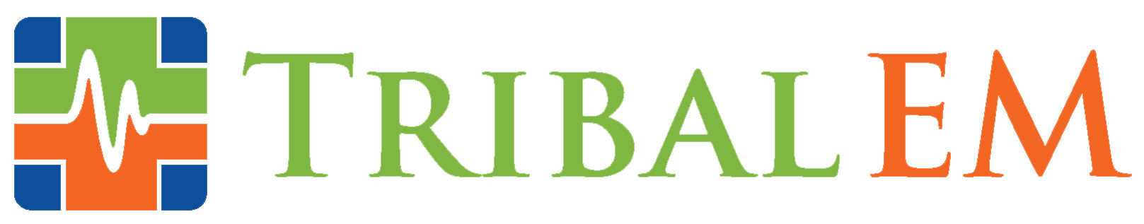

Tribal EM Launches New Diversity, Equity, and Inclusion Program, Hires Melody Lewis as DEI Director

SCOTTSDALE, Ariz. (July 8, 2021) – Tribal EM, the leader in tribal healthcare consulting and staffing, announced their creation of a new Diversity, Equity, and Inclusion program. Melody Lewis, Mojave/Tewa/Hopi and an enrolled member of the Fort Mojave Indian Tribe, will lead the program as Director of DEI. Lewis is a social entrepreneur experienced in systems of workforce development, education, and capacity building, utilizing collaborative approaches rooted in Indigenous identity.

In serving Tribal healthcare facilities across the country, Tribal EM’s mission focuses on providing culture-centric, compassionate care to address Native American and Alaskan Native healthcare disparities. While all Tribal EM healthcare professionals are trained in cultural competency and informed care delivery, the DEI program will offer new initiatives and education modules aimed at ensuring all staff, clients, and patients experience a positive culture that is respectful, equitable, and inclusive of diverse perspectives and backgrounds.

“At Tribal EM, we focus on transforming Indigenous healthcare – but another important part of our mission is personal and professional growth,” said Morgan Haynes, Chief Operations Officer. “Our diversity and inclusion values are a reality we consciously live every day. Our objective is to encourage positive awareness, honest dialogues, and ensure we provide an empathetic experience for all our patients and colleagues. Melody’s impressive background spans cutting-edge workforce development and Indigenous community building, which makes her the perfect leader to guide this effort.”

Lewis brings to the task 12 years of expertise in working with Indigenous communities and building capacity for those serving Indigenous populations. As Director of Diversity, she will support strategic initiatives that will establish a foundation of diversity, equity, and inclusive practices that empower and strengthen the Tribal EM team at all levels. She will also lead the DEI Task Force, which has launched programs such as lunch and learns with guest speakers, an employee hotline, and a book club where employees discuss themes of diversity, transformation, and healthcare disparities. Lewis also serves on the Tribal EM Advisory Board.

Lewis stated that she is excited to fuse her workforce and community knowledge with the Tribal EM mission.

“I came from a community rooted in my Indigenous culture, which focuses on putting community needs ahead of individual needs. My life experiences showed me what it’s like being a Native in spaces where a very small percentage of us are represented,” she said. “There is a process where Indigenous communities and individuals have to bridge their westernized urban experiences to align with their cultural values. This process is something I hope to share to revitalize the Indigenous perspective to best serve Tribal communities.”

About Tribal EM
Tribal EM provides medical expertise, quality assurance, process improvement, and staffing services to tribal healthcare facilities nationwide. The only organization of its kind, Tribal EM is committed to transforming Native American and Indigenous communities from within, improving access to care, empowering local providers, and delivering high quality, culturally sensitive care that is tailored to the needs of the patient population. Learn more at tribalem.com.

# # #

