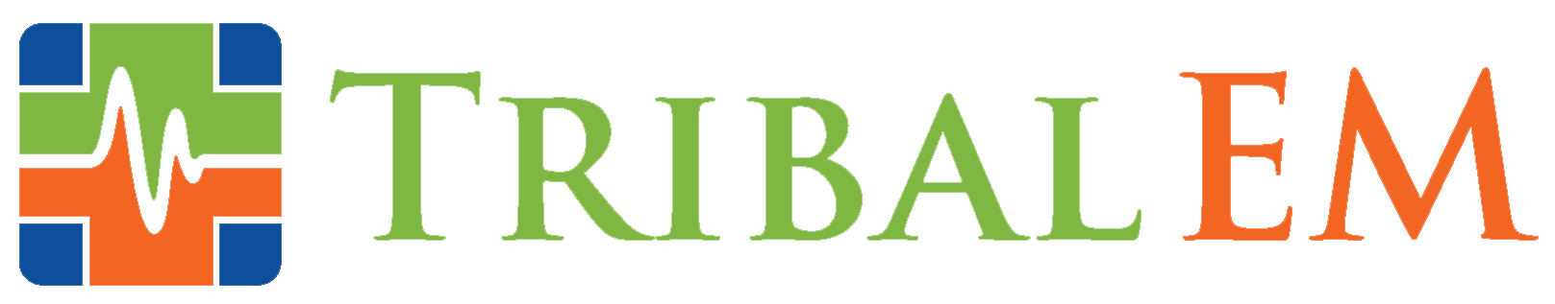

Tribal EM Expands to Support Rapid Growth, Transform Tribal Healthcare Facilities
Practice management and healthcare staffing company brings medical expertise, clinical education, to tribal communities in need

SCOTTSDALE, Ariz. (Feb. 25, 2021) – Tribal EM, the leader in tribal healthcare consulting, staffing and emergency medicine, announced a continuing streak of rapid growth in leadership, capabilities, and staff. In addition to the COVID-19 pandemic that has disproportionately impacted Native American populations, these communities face a long history of provider shortages, underfunding, and chronic resource scarcity. To address these disparities, Tribal EM brings a private healthcare model and culturally informed care to tribal hospitals and clinics. Since being founded in 2015, the company has expanded its contracts across the country to drive rapid year-over-year growth and become a dominant resource in Indigenous healthcare.

In the last year, the company expanded its presence from three to 13 states, expanded its base of emergency management, critical care response and locum tenens providers by 22%, and aided 17 new healthcare facilities in remote tribal regions. In addition to hiring more than a dozen new support staff, the company filled the following key positions:

- Chief Technology Officer, Rob Alexander
- Vice President of Human Resources, Greg Furstner
- Communications Director, Valerie Fenyn
- Director of Recruiting, Joe Buckley
- Operations Manager, Stephanie Lima

Tribal EM’s expansion has helped connect federal and tribal facilities to medical expertise during the COVID-19 pandemic – contributing emergency medicine physicians, nurses, and locum tenens staff to meet high demand. In the past year, Tribal EM has also added 20 new specialties to its clinical roster, including long-term care, pharmacy, dentistry, ophthalmology, general surgery, internal medicine, respiratory therapy, critical care, paramedics, and emergency medical technicians (EMTs) to further dissolve Native American healthcare barriers.

“Tribal communities face some of the most striking disparities in healthcare and health status in the nation,” said Morgan Haynes, Chief Operations Officer of Tribal EM. “Transforming these communities requires first-rate medical professionals who are passionate about making a mark on this world. It’s not easy, but it’s extremely rewarding. Our work doesn’t just impact a healthcare facility. Improved access to care and clinical expertise has positive ripple effects throughout tribal populations for generations.”

Healthcare providers interested in joining Tribal EM’s team or pursuing locum tenens work can see open positions and career opportunities here.

About Tribal EM
Tribal EM provides medical expertise, quality assurance, process improvement, and staffing services to tribal healthcare facilities nationwide. The only organization of its kind, Tribal EM is committed to transforming Native American and Indigenous communities from within, improving access to care, empowering local providers, and delivering high quality, culturally sensitive care that is tailored to the needs of the patient population.

# # #

Contact:
Valerie Fenyn
Tribal EM Communications Director
(602) 206-4847
vfenyn@tribalem.com

